AWS cloud Security Baseline & CSPM Governance Document
Organization: Cloud Architecture
Document Version: 1.0
Date: January 2026

Field | Description | Comments
Version | Document version number | 1.0
Date | Date of version release or update. | 27-Oct-2025
Author | Nagarajan C Y | Architect
Reviewer |  | CloudOps
Approver |  | Head of cloud engineering
Status | Initial Draft | Initial Draft

Contents

1 Summary 3
2 Scope & Applicability 4
2.1 Management (Root) Account 4
2.2 Control Tower Core Accounts 4
2.3 Workload Accounts 5
2.4 Region Scope 5
2.5 Control Tower Guardrail Applicability 5
2.6 Identity & Access Management Scope 6
2.7 Security Services Within Scope 7
2.8 Automated Remediation Applicability 7
2.9 Out-of-Scope Items 8
3 Cloud Security Posture Management (CSPM) Architecture 8
3.1 Organizational CSPM Model - Summary 8
3.2 Security Hub Delegated Administrator Configuration 9
3.3 CSPM Detection and Signal Sources 9
3.3.1 Security Hub Controls (Core CSPM Engine) 9
3.3.2 AWS Config 10
3.3.3 AWS CloudTrail 10
3.3.4 Integrated Security Services 10
3.4 Centralized Findings Aggregation and Visibility 11
3.5 Severity Normalization and Risk Prioritization 11
3.6 Event-Driven Alerting and Response 11
3.7 Automated Remediation Architecture 12
3.7.1 Automated Remediation Architecture 12
4 Appendix 14

Summary

This document establishes the AWS Cloud Security Baseline applicable to all AWS accounts governed within the AWS Organization and defines mandatory security controls to protect the confidentiality, integrity, and availability of cloud resources. AWS Control Tower is used to enforce standardized landing zone configurations and governance across all accounts, while AWS Security Hub operates as the centralized Cloud Security Posture Management (CSPM) platform for continuous security control monitoring.

The security baseline aligns with AWS Foundational Security Best Practices, CIS AWS Foundations Benchmark v5.0.0, and NIST Special Publication 800-53, with Security Hub aggregating compliance evidence from AWS Config, CloudTrail, GuardDuty, Inspector, and IAM Access Analyzer. Preventive, detective, and corrective controls are implemented to reduce security risk and configuration drift, supported by automated remediation using EventBridge, AWS Lambda, and AWS Systems Manager to address non-compliant findings.

All accounts provisioned through Control Tower Account Factory inherit the security baseline by default at onboarding, ensuring Day-0 compliance and continuous enforcement throughout the account lifecycle. Security exceptions are managed through a documented risk acceptance and approval process, with approvals being time-bound and subject to periodic review. Compliance posture and remediation effectiveness are continuously measured and reported, and evidence produced by the CSPM platform supports ongoing assurance activities, enabling sustained compliance with ISO 27001 and SOC 2 through standardized, auditable, and repeatable security controls

Scope & Applicability

This Cloud Security Baseline applies to all AWS accounts within the enterprise AWS Organization, including the Management account, Control Tower core accounts, and all workload accounts provisioned through AWS Control Tower.
The baseline is enforced consistently across all in-scope accounts and regions using Control Tower guardrails, AWS Organizations policies, and centralized security services such as AWS Security Hub, AWS Config, and CloudTrail.

All accounts inherit mandatory preventive, detective, and corrective controls by default, with any exceptions subject to formal risk assessment, approval, and periodic review.

Management (Root) Account
The Management (Root) account hosts AWS Organizations, Control Tower, and consolidated billing, and is restricted to break-glass administrative access only with no application workloads permitted.
Security is enforced through SCPs, centralized logging and monitoring, and AWS IAM Identity Center integrated with Microsoft Entra ID for centralized authentication and access governance

Control Tower Core Accounts
Control Tower Core Accounts (Log Archive, Audit/Security, and Networking) provide centralized logging, security monitoring, and shared network services for the entire AWS Organization.
These accounts are always in scope, cannot be exempted from the security baseline, and host mandatory governance and security services. They enforce organization-wide detective and preventive controls to ensure continuous compliance and centralized oversight.
Account Type | Purpose | Applicability
Log Archive | Centralized CloudTrail, Config, and access logs | Mandatory
Audit | Security Hub, GuardDuty, Config aggregators | Mandatory
Networking | Firewall,VPCs, Transit Gateway, DNS | Mandatory

These accounts are always in scope for the security baseline and cannot be exempted from any mandatory controls. They enforce organization-wide detective and preventive controls to ensure consistent governance, continuous monitoring, and compliance across all AWS accounts

Workload Accounts

Workload accounts in AWS are accounts dedicated to running application workloads such as development, testing, and production environments. They are isolated from each other and centrally governed to improve security, compliance, and operational management.

Account type
Production
Shared Services
Staging
Test

All workload accounts:
- Are provisioned via Control Tower Account Factory
- Inherit mandatory guardrails
- Must comply with Security Hub baseline controls
- Are subject to continuous monitoring and remediation

Region Scope
Security controls apply to all AWS regions enabled within the organization.

Control Tower Guardrail Applicability

AWS Control Tower enforces preventive and detective guardrails that are automatically applied to all enrolled accounts. Preventive guardrails, implemented using Service Control Policies (SCPs), block non-compliant actions at the API level such as disabling CloudTrail, creating public S3 buckets, or modifying log archive buckets. Detective guardrails are implemented through AWS Config rules to identify and report non-compliant resources. These findings are centrally aggregated and fed into AWS Security Hub for visibility and compliance tracking. All accounts enrolled in Control Tower inherit these guardrails by default, ensuring consistent security enforcement across the organization.
Preventive Guardrails
- Enforced using Service Control Policies (SCPs)
- Block non-compliant actions at the API level
Detective Guardrails
- Implemented using AWS Config rules
- Detect and report non-compliant resources
- Feed findings into AWS Security Hub
All accounts enrolled in Control Tower inherit these guardrails by default.

Identity & Access Management Scope
The security baseline applies to all human access to AWS accounts managed through AWS IAM Identity Center (SSO). This includes all federated identities authenticated using Microsoft Entra ID, ensuring centralized identity governance and consistent access control across the organization.
The baseline applies to:

All human user access to AWS accounts
All federated identities authenticated via Microsoft Entra ID
Key principles:
- No long-term IAM users in workload accounts
- Authentication via:
  - Entra ID → IAM Identity Center federation
- Authorization via:
  - Permission Sets
  - Account-level assignments
- Access governed by:
  - Least privilege
  - Role separation (Admin / PowerUser / ReadOnly)
Privileged Access Scope
- Root users:
  - Locked down
  - MFA enforced
  - Monitored continuously
- Break-glass roles:
  - Logged
  - Time-bound
  - Audit-approved

Security Services Within Scope
The following AWS services are centrally enabled and in scope:
Service | Purpose
AWS Security Hub | Central CSPM platform
AWS Config | Configuration compliance
AWS CloudTrail | API activity logging
Amazon GuardDuty | Threat detection
AWS Inspector | Vulnerability scanning
IAM Access Analyzer | Permission analysis
AWS Organizations | Account governance

All findings are:
- Aggregated centrally
- Retained per compliance requirements
- Used as audit evidence

Automated Remediation Applicability
Automated remediation is applied across all applicable accounts to detect and correct high-risk security misconfigurations through centralized, event-driven controls.
Automated remediation applies to:
All non-production and production accounts
All high-risk findings, including:
- Public access
- Missing encryption
- Disabled logging
- Over-permissive IAM policies
Mechanisms:
- Amazon EventBridge
- AWS Lambda
AWS Systems Manager Automation
Sandbox accounts:
- May have limited remediation
- Must still generate findings and alerts

Out-of-Scope Items
The following are explicitly excluded unless otherwise approved:
- Standalone AWS accounts not enrolled in the AWS Organization
- Third-party SaaS platforms outside AWS
- On-premises infrastructure (covered under separate policy)
- Personal AWS accounts
- Temporary proof-of-concept accounts not governed by Control Tower

Cloud Security Posture Management (CSPM) Architecture
This section defines the Cloud Security Posture Management (CSPM) architecture implemented across the AWS Organization. CSPM provides continuous visibility, compliance monitoring, and governance of cloud resources to ensure alignment with security standards, regulatory requirements, and internal security policies.

AWS Security Hub is implemented as the centralized Cloud Security Posture Management (CSPM) platform within the Audit account and configured as the delegated administrator for the AWS Organization. Security Hub aggregates security and compliance findings from all member accounts, evaluates resources against industry benchmarks, provides centralized visibility and reporting, and enables event-driven automated remediation. This architecture ensures continuous compliance, audit readiness, and Day-0 security posture enforcement across all AWS environments.
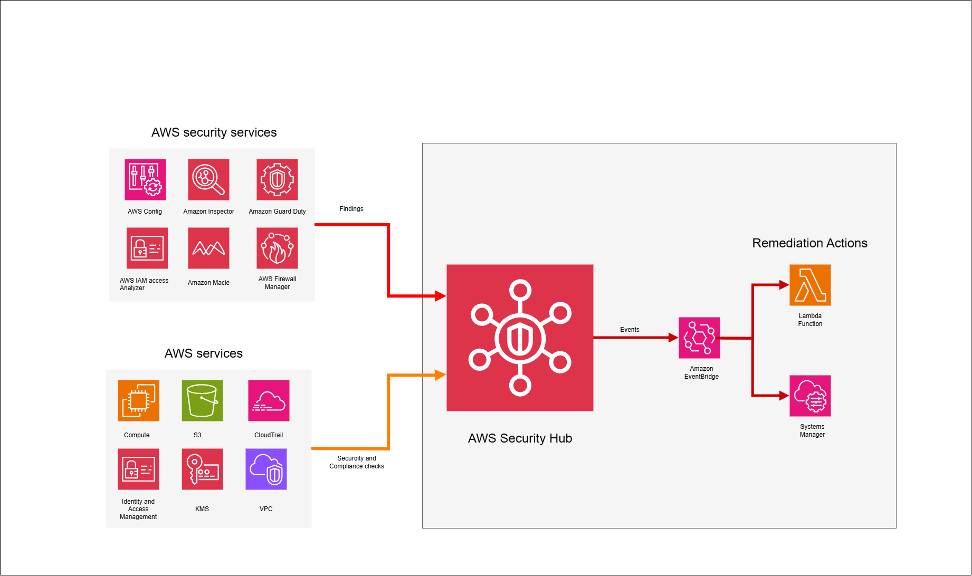
Security Hub Findings flow

Organizational CSPM Model - Summary
The CSPM architecture is implemented using a hub-and-spoke model aligned with AWS Organizations and Control Tower. The Management account governs organizational structure and lifecycle, while the Audit account acts as the central security hub, serving as the delegated administrator for AWS Security Hub and aggregating CSPM findings across all member accounts. The Log Archive account provides centralized, immutable storage for CloudTrail and AWS Config logs to support compliance and forensic analysis. Workload accounts (Dev, Test, UAT, Prod, and Shared Services) generate security posture findings and telemetry. Security posture data flows upward to the Audit account for centralized visibility and reporting, while governance controls, policies, and automated remediation actions are enforced downward across workload accounts.
The CSPM architecture follows a hub-and-spoke organizational model
Account roles:
- Management Account
  - AWS Organizations governance
  - Control Tower lifecycle management

- Audit Account (Security Tooling Account)
  - AWS Security Hub delegated administrator
  - Central aggregation of all security findings
  - Compliance reporting and governance
- Log Archive Account
  - Centralized retention of CloudTrail and AWS Config logs

- Workload Accounts
  - Dev, Test, Sandbox, POC, PROD
Design principle: Security posture data flows upward to the Audit account, while governance and remediation policies flow downward to workload accounts.

Security Hub Delegated Administrator Configuration
AWS Security Hub is centrally managed using an organization-wide delegated administrator model, with the Audit account designated as the Security Hub Delegated Administrator and auto-enable applied across AWS Organizations. This ensures all existing and newly provisioned accounts are automatically enrolled, cannot opt out, and maintain Day-0 CSPM coverage with no security visibility gaps.
Key configuration elements:
- Audit account is designated as the Security Hub Delegated Administrator
- Security Hub is enabled with organization auto-enable
- All existing and future AWS accounts are automatically enrolled
- Member accounts cannot independently disable Security Hub
This ensures Day-0 CSPM coverage for all newly provisioned accounts and prevents security visibility gaps.

CSPM Detection and Signal Sources

AWS Security Hub aggregates and normalizes security findings from multiple AWS-native services.

Security Hub Controls (Core CSPM Engine)
Security Hub continuously evaluates AWS resources against enabled benchmarks, including:
- AWS Foundational Security Best Practices (FSBP)
- CIS AWS Foundations Benchmark v5.0.0
- NIST Special Publication 800-53 Revision 5
Each control produces compliance findings indicating PASS or FAIL, along with severity and remediation guidance.

AWS Config
AWS Config enforces detective controls by continuously evaluating AWS resource configurations against approved security baselines and identifying configuration drift. It detects non-compliant conditions such as public S3 buckets, disabled encryption or logging, and overly permissive security group rules. All AWS Config findings are automatically forwarded to AWS Security Hub for centralized visibility and compliance reporting.

AWS CloudTrail
AWS CloudTrail delivers comprehensive audit visibility by recording API activity, console logins, role assumptions, and configuration changes across all AWS accounts. This activity data enables accurate attribution of security findings to specific identities and actions. It also supports forensic investigations and provides verifiable audit evidence for compliance and governance purposes.

Integrated Security Services
AWS Security Hub centrally aggregates security findings from native AWS services including GuardDuty for threat detection, Inspector for vulnerability management, IAM Access Analyzer for public and cross-account access analysis, and optionally Macie for sensitive data discovery. All incoming findings are standardized using the AWS Security Finding Format (ASFF) to ensure consistency. This enables unified analysis, correlation, and reporting across the organization.
    - Amazon GuardDuty – threat detection
    - Amazon Inspector – vulnerability management
    - IAM Access Analyzer – public and cross-account access analysis
    - (Optional) Amazon Macie – sensitive data discovery

CloudTrail provides authoritative audit logs that are consumed by AWS Config, GuardDuty, and other security services, which then generate normalized findings centrally aggregated in AWS Security Hub.
Service | Uses CloudTrail data | Sends findings to Security Hub
CloudTrail | - | NO
AWS Config | Indirectly | Yes
GuardDuty | Yes | Yes
IAM Access Analyzer | Partial | Yes
Security Hub controls | Config-Based | Yes

Centralized Findings Aggregation and Visibility
All security findings generated in workload accounts are automatically forwarded to the Audit account.
Aggregation flow:
- Finding generated in workload account
- Finding normalized into ASFF
- Finding forwarded to Audit account Security Hub
- Central dashboards and reports updated
This provides a single authoritative view of cloud security posture across the organization.

Severity Normalization and Risk Prioritization
Security Hub in the Audit account normalizes and enriches findings, correlates related risks, and enables environment-aware, risk-based prioritization and response.
- Normalizes severity levels (Critical, High, Medium, Low)
- Enriches findings with:
  - Account ID
  - Environment classification
  - Resource metadata
- Correlates related findings
This enables risk-based prioritization and environment-aware response workflows.

Event-Driven Alerting and Response

Security Hub integrates with Amazon EventBridge to enable automated alerting and response.
Event routing capabilities:
- Filter findings by:
  - Severity
  - Control ID
  - Account or environment
- Route findings to:
  - Automated remediation workflows
  - SNS (email notifications)

Automated Remediation Architecture

Automated remediation uses Security Hub findings to trigger EventBridge-driven workflows that invoke Lambda and SSM Automation to automatically correct high-risk misconfigurations across accounts, ensuring rapid, consistent, and policy-driven risk reduction.
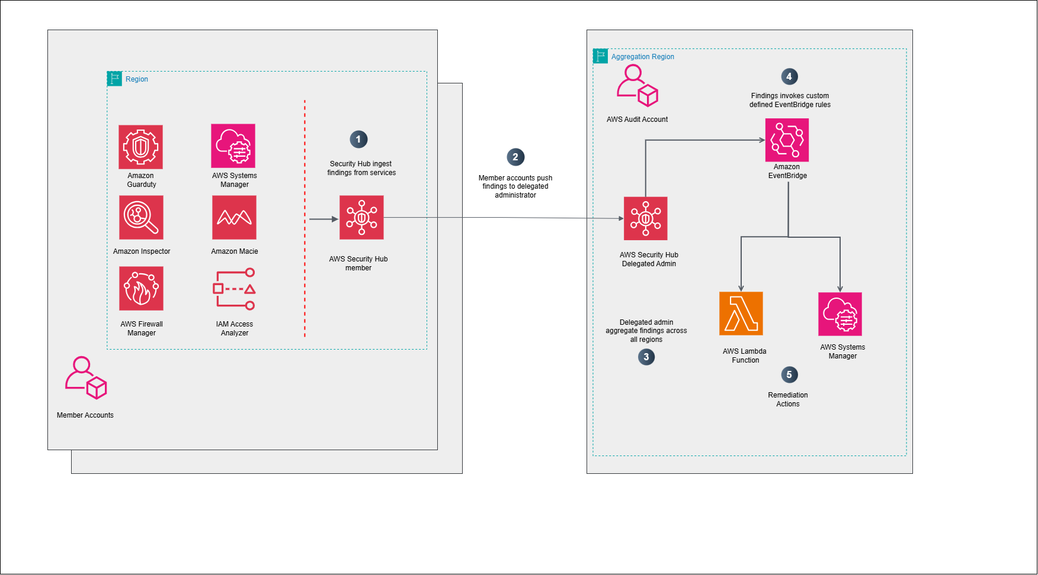
Security Hub Architecture

Automated Remediation Architecture
Step 1 — Finding generated (Security Hub)
- A control triggers (Security Hub Security Standards, AWS Config rule, GuardDuty, Inspector, IAM Access Analyzer, etc.).
  - The finding is normalized into ASFF and includes:
  - ProductName, GeneratorId (which control produced it)
  - Severity (Critical/High/Medium/Low)
  - Resources[] (ARNs and resource type)
  - AwsAccountId, Region, timestamps
  - Workflow fields (NEW / NOTIFIED / RESOLVED)
- Outcome: A consistent “event payload” is available to drive automation.
Step 2 — EventBridge rule matches criteria
- An EventBridge rule in the Audit (delegated admin) account subscribes to Security Hub finding events and filters.
Step 2 — EventBridge rule matches criteria
- A remediation Lambda typically does the following
  - Validation / safety checks
    - Confirm finding is still valid (resource still exists, still non-compliant)
    - Ensure it’s not an allowed exception (tags like SecurityException=true, approved CIDRs, known public buckets for websites, etc.)
    - Confirm environment policy (NonProd auto-fix allowed; Prod requires approval gate)
  - Cross-account execution: Assume a member account remediation role (STS AssumeRole)
- Choose the action path: Simple fixes can be done directly by Lambda (e.g., revoke a SG rule). (refer Mapping table in the following section for all controls in place)

Appendix

